**DLD LAB 11 – IN LAB AND HOME TASKS**

**Task 01:**

|  |  |  |  |
| --- | --- | --- | --- |
| **Inputs** | | | **Outputs** |
| **S3** | **S2** | **S1** | **Y** |
| 0 | 0 | 0 | D1 |
| 0 | 0 | 1 | D2 |
| 0 | 1 | 0 | D3 |
| 0 | 1 | 1 | D4 |
| 1 | 0 | 0 | D5 |
| 1 | 0 | 1 | D6 |
| 1 | 1 | 0 | D7 |
| 1 | 1 | 1 | D8 |

**Task 02:**

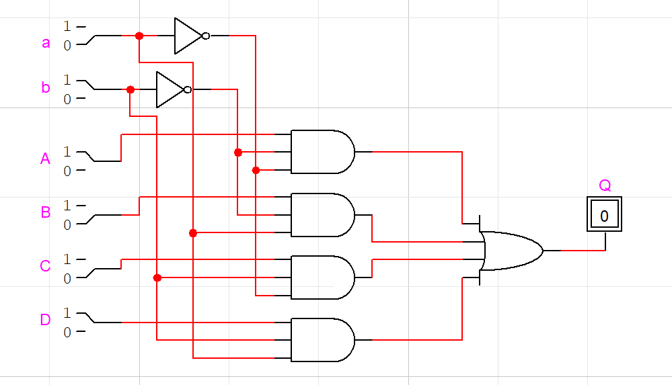

**Task 03**

